B502 – How to Do a Rate Shop

Find the least expensive rate at a location for the specified time period.

Mandatory Fields:

Enter RS in the top left corner of the screen.

BCD: Enter BCD# (optional)
STA: 4/5-digit Maestro station number or 3-letter mnemonic code
ETA: Date/Time (time is in 24hr format – e.g. 01FEB10/1300)
RTN: 4/5-digit Maestro station number or 3-letter mnemonic code
ETR: Date/Time (time is in 24hr format – e.g. 01FEB10/1300)
VCL: 1-character car group code

Press Enter.

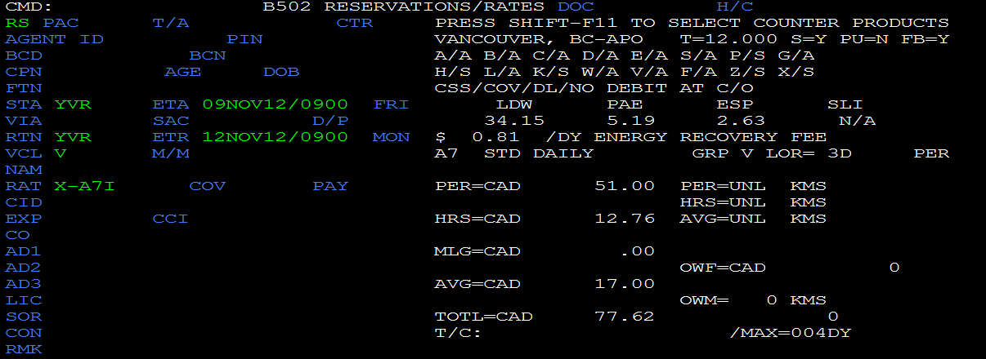

Tip:
1. Press F9 beside any field for more information.

